Use of AI

Declaration:
I acknowledge the use of ChatGPT to help me understand certain concepts and help refine my sentences. The output was modified by applying the learned concepts and I checked the accuracy of any information, data or sources generated by cross checking with online sources.

Justification:
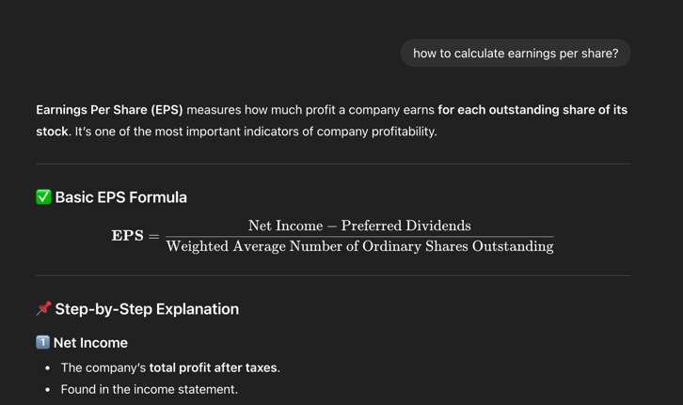
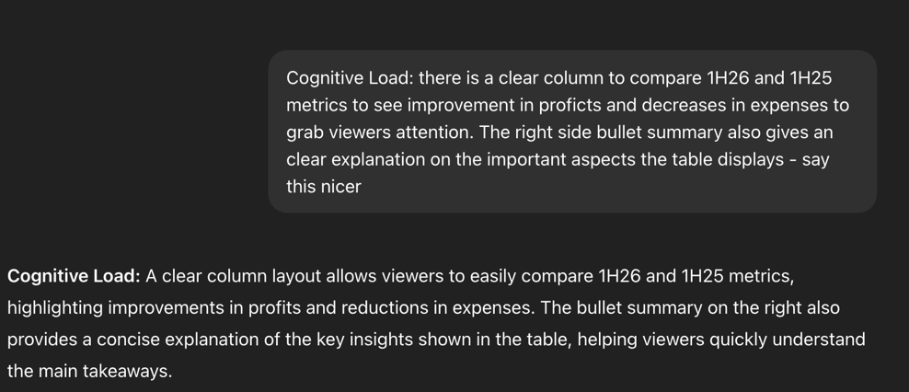
I used ChatGPT to help me better understand some of the financial concepts used in this assignment, as I do not have a strong background in stock markets. It was helpful in explaining concepts such as EPS, P/E ratios and information presented in the slides. This helped me to apply these concepts correctly in my analysis. I also used ChatGPT to improve formality of words and help my writing, by refining sentences and vocabulary. This helped make my explanations clearer and more brief. Overall, I found ChatGPT useful as a support tool for learning unfamiliar concepts and improving the quality of my writing. Below I have attached screenshots for example.

Link to transcript:
https://chatgpt.com/share/69ac328d-dec4-800a-97ef-72473a3f89d7

(Next page is the transcript attached)

